FOR IMMEDIATE RELEASE
WaterFront: Making Craft Part of Your Life

WaterFront Craft Art Market 2014
Kiwanis Park North (Spadina Cres. & 22nd St)
Saturday, June 28 from 10am – 7pm
FREE Admission

The Saskatchewan Craft Council invites the public to the WaterFront Craft Art Market.

WaterFront is a one-day outdoor sale of fine craft and original art. The sale and show features the work of over 40 talented Saskatchewan craft artists, including 5 New and Emerging Artists. Shoppers will find contemporary craft from makers like Alison Brandt Malinski of Who New Creations, Shauna Buck Illustrations, and jeweller Laura Steadman of EllJay Design. Established fine craft artisans such as glass artists Joan and All Hiebert of InGlassland, jeweller Winston Quan of Handmade House, and Bonnie Gilmour & Charley Farrero from Meacham will also be at WaterFront. Each artist has undergone a rigorous jury process by the Saskatchewan Craft Council, to ensure only the highest quality craft is featured at SCC markets.

In addition, the SCC is partnering with SaskMusic to present the SaskMusic Stage at WaterFront, featuring live music from local musicians. Visitors to WaterFront can also partake in live craft demonstrations, children’s activities, including workshops with the Saskatoon Juggling Club and enjoy swing dance demonstrations and lessons by Saskatoon Lindy Hop.

Find the festival on Facebook via the Saskatchewan Craft Council page.

For more information please contact:
Ferron Olynyk, SCC Member Services
Saskatchewan Craft Council Phone: 306-653-3616, ext. 24
813 Broadway Avenue Email: scc.memberservices@sasktel.net
Saskatoon, SK S7N 1B5 Website: www.saskcraftcouncil.org

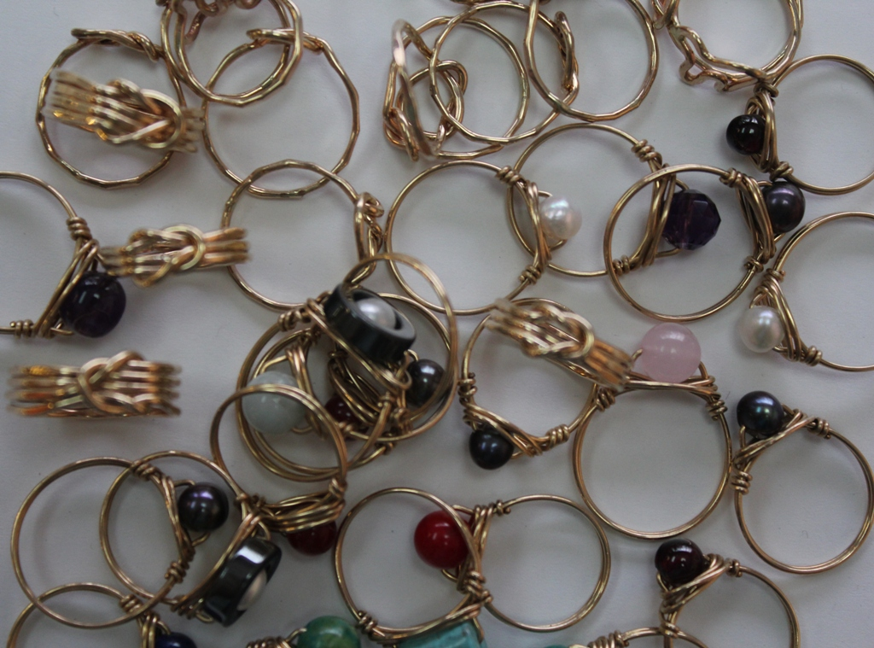
_{Winston Quan Jewellery}

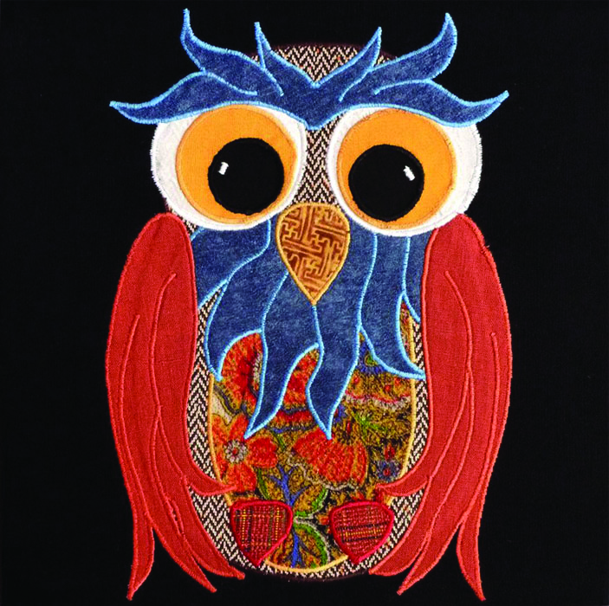
Allison Brandt Malinski Who New Creations

