
FOR IMMEDIATE RELEASE

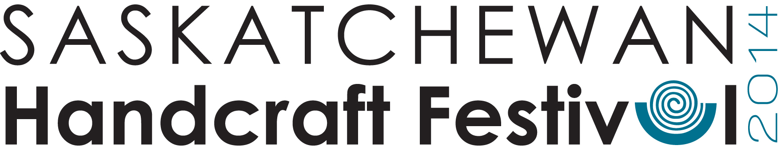

Live Craft Demonstrations at Saskatchewan Handcraft Festival

Saskatchewan HandCraft Festival 2014
Alex Dillabough Centre, 421 28th St W, Battleford, SK
July 18-20, 2014

Visitors to the Saskatchewan Handcraft Festival will be delighted to see and participate in live craft demonstrations by Saskatoon-based artisans Monika Kinner-Whalen and Teresa Gagne.

Monika is a full-time fibre artist living and working in Saskatoon, specializing in freestyle embroidery. She says about her work: “My creations are expressions of my love for the prairies and often originate from my own personal photographs of Saskatchewan. I am constantly amazed by the texture and intricate beauty that can be achieved by working with threads.”
Monika will demonstrate threadpainting, and will also have a “tapestry table” for kids to try their hand at stitching!
Demonstrations Friday 12:30-3:30 and Saturday 2-5

Teresa Gagne approaches clay in a playful and creative way. By using a variety of surface treatments and firing methods for her architectural, decorative and functional ceramics, Teresa strives to make well-crafted, aesthetically pleasing pottery that brings pleasure in daily life and for special occasions. Teresa will demonstrate various pottery techniques including hand building
Demonstrations Friday 4-7 and Saturday 10-1

Craft demonstrations are possible thanks to funding from Tourism Saskatchewan

Saskatchewan Handcraft Festival
Friday July 18, Noon – 7pm Admission for a 3-day pass:
Saturday July 19, 10am-6pm $5 for Adults, $3 for Seniors & Youth,
Sunday July 20, 10am-4pm Children 12 and under FREE

For a complete list of marketers, visit:
www.saskcraftcouncil.org/memb-prod/markets/shf.php
--
For more information please contact:
Ferron Olynyk, SCC Member Services
Saskatchewan Craft Council Phone: 306-653-3616, ext. 24
813 Broadway Avenue Email: scc.memberservices@sasktel.net
Saskatoon, SK S7N 1B5 Website: www.saskcraftcouncil.org


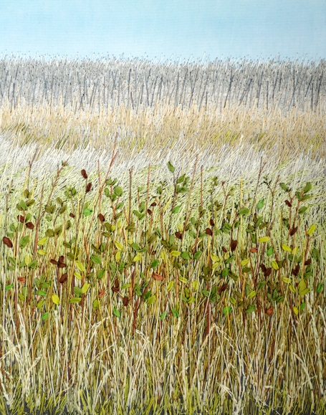
_{Monika Kinner-Whalen}

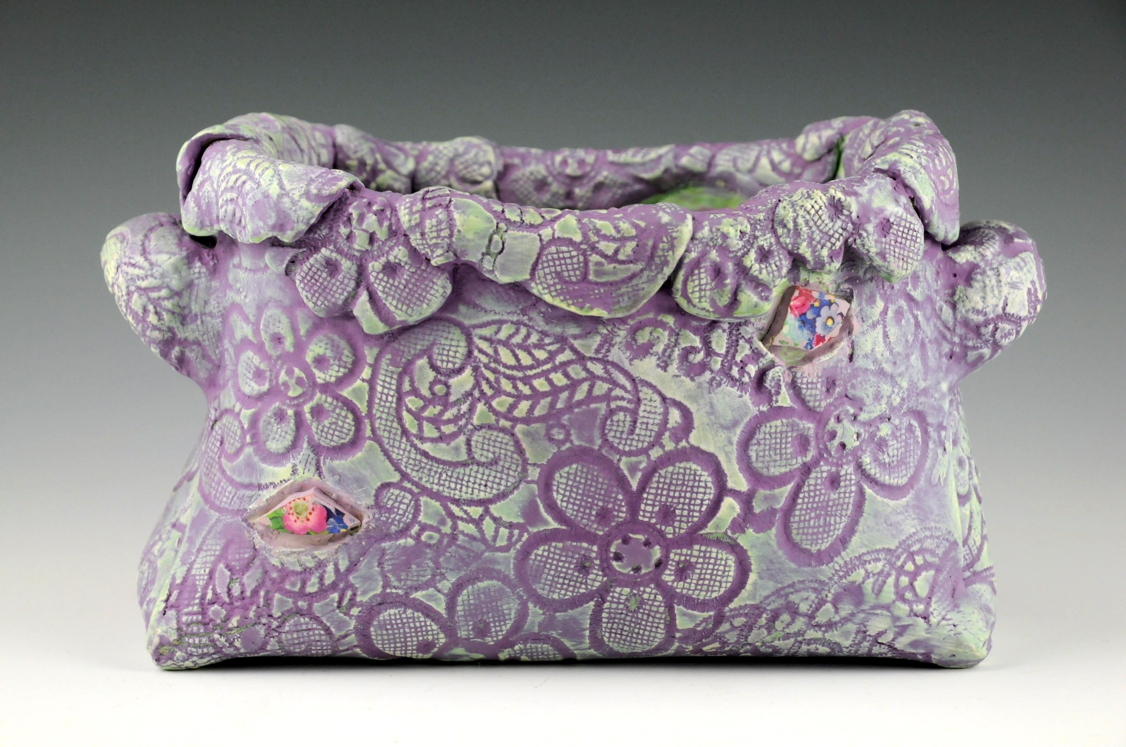
_{Teresa Gagne}

