FOR IMMEDIATE RELEASE
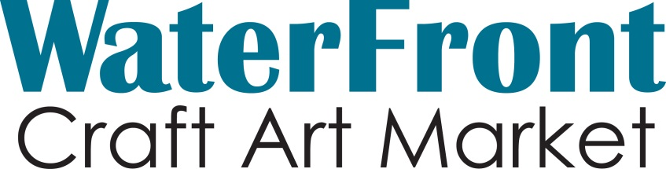
Like a Rolling Stone: Be Part of Art
Heike Fink of Feltastic Fibre and the Placemaker Program at WaterFront

WaterFront Craft Art Market 2014
Kiwanis Park North (Spadina Cres. & 22nd St)
Saturday, June 28 from 10am – 7pm
FREE Admission

WaterFront is a one-day outdoor sale of fine craft and original art and features the work of over 30 talented Saskatchewan artists. Each marketer has undergone a rigorous jury process by the Saskatchewan Craft Council, to ensure only the highest quality product is featured at SCC markets. WaterFront also includes 5 Emerging Artists, as well as the SaskMusic stage featuring local musicians!

In addition to buying fine craft and art, visitors are invited to partake in Heike Fink’s pebble felting workshop, part of the City of Saskatoon’s Placemaker Program.

“Do you like the South Saskatchewan River with all its pebbles? Have you ever wondered about the geology and history of those pebbles? Be Part of Art and create your own Rolling Stone - a felted soft pebble, which your imagination can fill with your own personal history, thoughts and wishes for the present and future.
The woolen pebbles will be felted in several workshops and will be combined into one piece of art at River Landing during Cultural Days on September 27, 2014.
Come to our workshops, learn how to felt, make your own pebble, connect to the river’s and your own history and
Be Part of Art”

Heike will be making pebbles with the public from 10am-7pm at WaterFront

Find the festival on Facebook via the Saskatchewan Craft Council page.

For more information please contact:
Ferron Olynyk, SCC Member Services
Saskatchewan Craft Council Phone: 306-653-3616, ext. 24
813 Broadway Avenue Email: scc.memberservices@sasktel.net
Saskatoon, SK S7N 1B5 Website: www.saskcraftcouncil.org

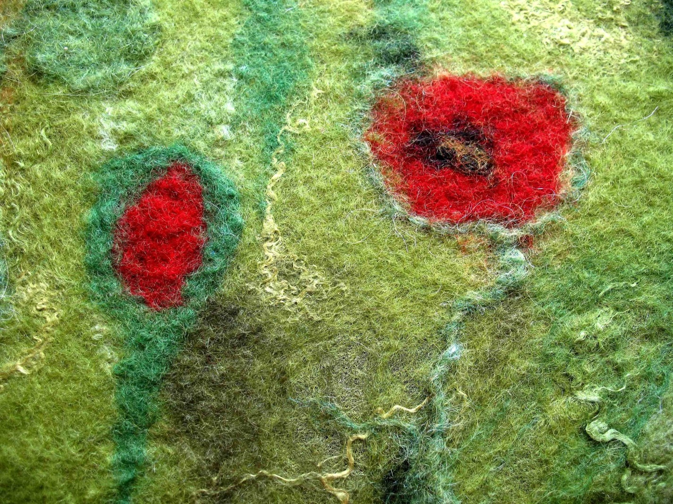
Heike Fink – Feltastic Fibre

